**Advanced Web Development – “Version Control Lab”**

**Kevin Kuo Raj Patel Mary Snyder**

Points: 10

Due: Night before next class

**Instructions:**

The aim of this lab is to set up the version control system for your project. You may want to look at the slides for version control on the blackboard

1. Set up your individual github accounts.

See screenshot in #2.

1. Set up a repository for your team project.

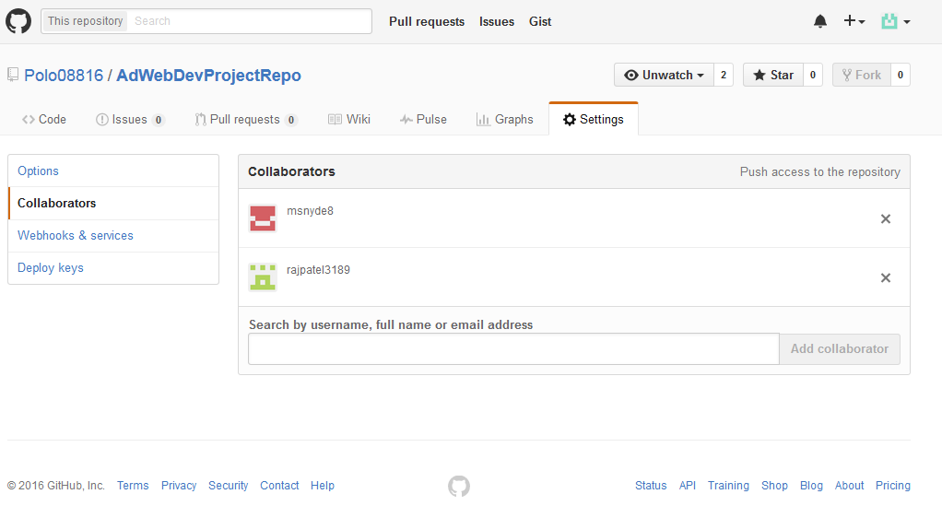

1. Setup the skeleton for your project. Every team member should download the repository on their machines.

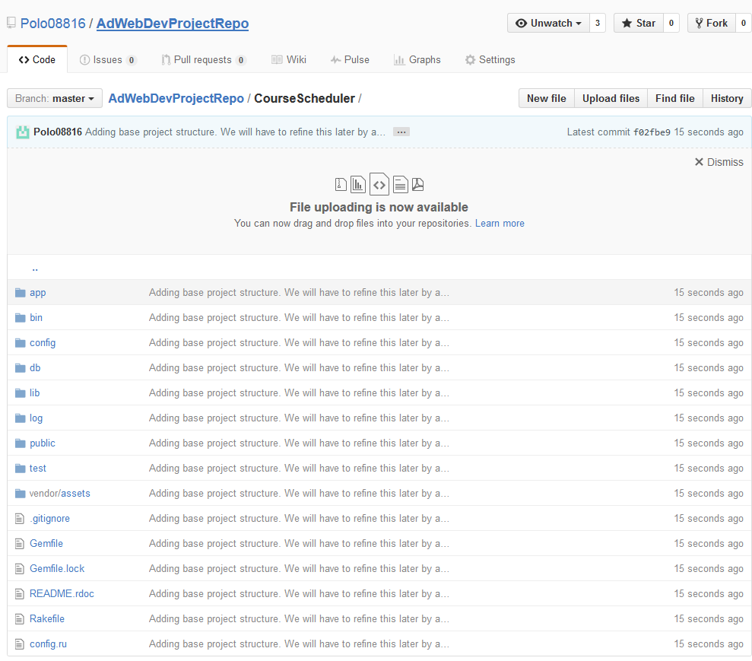

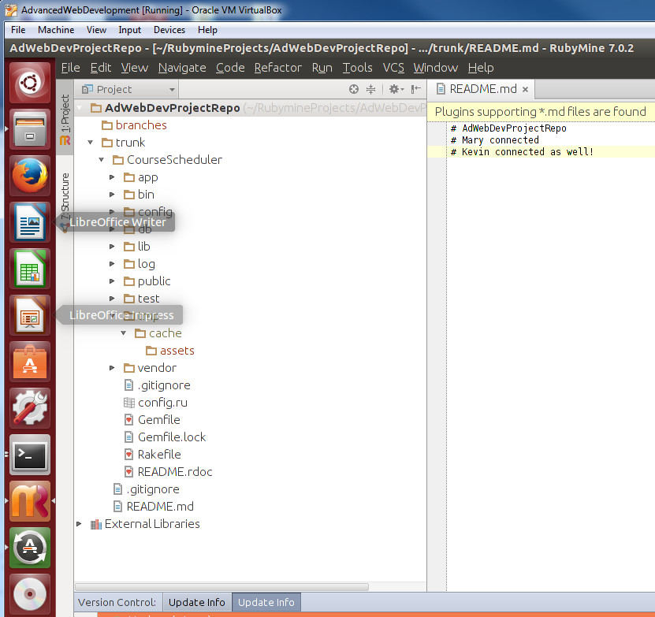

1. Go through a ‘mock’ exercise of changing the same file with two team members and resolving a conflict. See slides on version control on blackboard for the mock exercise.

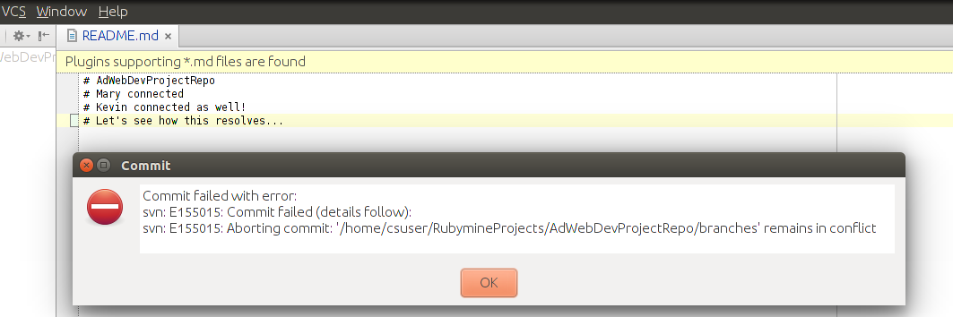

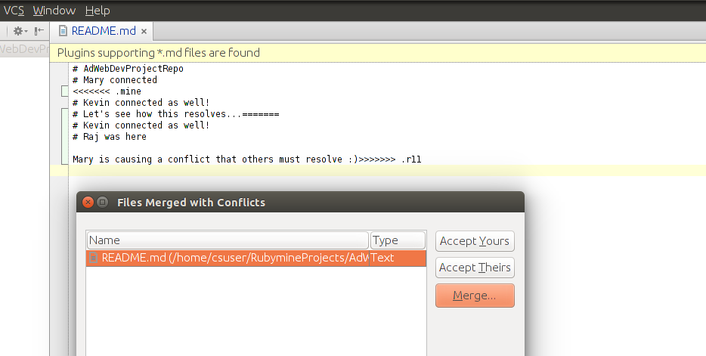

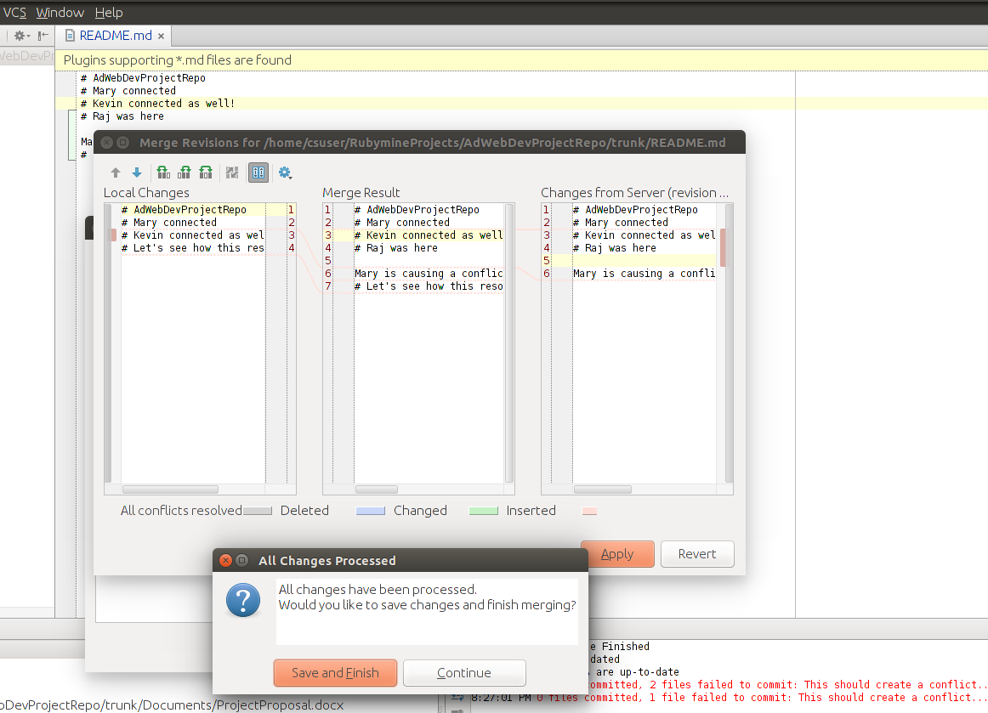

Readme.md conflict was resolved.